**NITUK-HEAL**

A project submitted to the National Institute of Technology, Uttarakhand in partial

fulfilment of the degree of

**Bachelor of Technology**

in

**Computer Science and Engineering**

By

**Chinmay Jain**

**BT12CSE001**

**Abhinav Kumar**

**BT12CSE009**



Department of Computer Science and Engineering

National Institute of Technology, Uttarakhand.

Srinagar (Garhwal) - 246174



***CERTIFICATE***

This is to certify that the project work, entitled ***“­­­­NITUK-HEAL”*,** submitted for partial fulfilment of the requirement for the award of degree of ***Bachelor of Technology in Computer Science and Engineering*** to the National Institute of Technology, Uttarakhand is a bona fide work carried out by ***Abhinav Kumar (*BT12CSE009***)* and under the guidance of **Mr. Maroti Deshmukh**.

The matter embodied in the project report has not been previously submitted for the award of other degree or diploma.

|  |  |
| --- | --- |
| **Project Guide** | **Head of Department** |
| **Mr Maroti Deshmukh** | **Mr Nitin Kumar** |
| **(Asst. Prof. NIT Uttarakhand)** | **(Dept. of CSE, NIT Uttarakhand)** |
|  |  |



***CERTIFICATE***

This is to certify that the project work, entitled ***“­­­­NITUK-HEAL”*,** submitted for partial fulfilment of the requirement for the award of degree of ***Bachelor of Technology in Computer Science and Engineering*** to the National Institute of Technology, Uttarakhand is a bona fide work carried out by ***Chinmay Jain (*BT12CSE009***)* and under the guidance of **Mr. Maroti Deshmukh** .

The matter embodied in the project report has not been previously submitted for the award of other degree or diploma.

|  |  |
| --- | --- |
| **Project Guide** | **Head of Department** |
| **Mr Maroti Deshmukh** | **Mr Nitin Kumar** |
| **(Asst. Prof. NIT Uttarakhand)** | **(Dept. of CSE, NIT Uttarakhand)** |

***DECLARATION***

I*,* ***Abhinav Kumar***, hereby declare that this project *entitled* ***“NITUK-HEAL”*,** submitted by meunder the guidance and supervision of ***Mr Maroti Deshmukh***, Assistant Professor, National Institute of Technology Uttarakhand, is a bona fide work. I also declare that it has not been submitted previously in part or in full to this institute or other university or institute for the award of any degree or diploma.

**Date:** 25 November 2014

**Name: Abhinav Kumar** Signature of the student

**Roll No:** BT12CSE009

**Contact:** +91 8979105585

***DECLARATION***

I*,* ***Chinmay Jain***, hereby declare that this project *entitled* ***“NITUK-HEAL”*,** submitted by meunder the guidance and supervision of ***Mr Maroti Deshmukh***, Assistant Professor, National Institute of Technology Uttarakhand, is a bona fide work. I also declare that it has not been submitted previously in part or in full to this institute or other university or institute for the award of any degree or diploma.

**Date:** 25 November 2014

**Name: Chinmay Jain** Signature of the student

**Roll No:** BT12CSE001

**Contact:** +91 9528377401

***ACKNOWLEDGEMENT***

I would like to take this opportunity to thank wholeheartedly the gracious souls without whom this project would have been unfulfilled dream.

I express my sincere gratitude to ***Mr. Maroti Deshmukh***, Assistant Professor, National Institute of Technology Uttarakhand, India, for his stimulating guidance, continuous encouragement and supervision throughout the course of present work.

I am extremely thankful to ***Professor H. T. Thorat***, Director, National Institute of Technology Uttarakhand for providing me infrastructural facilities to work in, without which this work would not have been possible.

Special thanks are due to National Institute of Technology Uttarakhand faculty for their constant support during this project work.

I would like to thank my B.Tech Friends for their constant source of encouragement, motivation and their help in my project is invaluable.

Finally I thank my parents for their love and encouragement in every phase of my life, without which nothing would have been possible.

*SINCERELY*

***Chinmay Jain (BT12CSE001)***

***Abhinav Kumar (BT12CSE009)***

ABSTRACT

Our project **NITUK-HEAL** aims to bring the medical details handy. It is a true web solution with centralized database where the personal and medical details of each person in the college can be maintained in a database. This system is accessible to only to the Medical Officers of our institute. It allows admin to login through a valid username and password and undertake various functionalities such as registering a new person & filling his details, editing & updating his details, maintaining records of prescriptions provided to him, deleting an existing person and searching for a person by attributes such as ID, name, blood group, health problems, vaccination, counselling areas, etc. The main objective of **NITUK-HEAL** is to automate some of the activities regarding maintaining the medical records of every person in the college. The main advantage of **NITUK-HEAL** is time saving eliminating the necessity to maintain a hardcopy of personal & medical data of each person, as all this can be done through **NITUK-HEAL**’s interface very easily.

Table of Contents

1. Introduction 10

2. Motivation 11

3. Background 13

3.1. MVC Framework: 13

3.2. SHA-256 Encryption: 15

3.3. Dynamic Database: 16

4. Project Specification 17

Project Description 22

4.1. Login Module 22

4.2. Update Module 23

4.3. Search Module 24

4.4. View Module 24

5. Methodology and Planning of work 28

5.1. Softwares 28

5.2. Programming Languages 30

5.3. Database Used 32

5.4. Technologies Used 33

6. Future Scope 38

7. Snapshots 39

8. References 51

Table of Figures

Figure 1 MVC Framework 14

Figure 2 SHA-256 Encryption 15

Figure 3 Database entities 21

Figure 4 Entity-Relationship diagram 21

Figure 5 Flowchart of NITUK-HEAL 27

Figure 6 JSP Model View Controller Design 34

Figure 7 MVC framework 36

Figure 8: StarPage 39

Figure 9 : Registration Page 39

Figure 10: Registration Success 40

Figure 11: Change Password 40

Figure 12 : Home NITUK-Heal 41

Figure 13: Log in 41

Figure 14: Register Person 42

Figure 15: Edit Prescription 42

Figure 16: Edit Basic Details 43

Figure 17: Edit Family Background 43

Figure 18: Edit Medical Details 44

Figure 19: Edit Medical History 44

Figure 20 : Edit existing person 45

Figure 21 : Edit Prescription 45

Figure 22 : Delete existing person 46

Figure 23 : Search person 46

Figure 24 : Search person 47

Figure 25 : Basic Details 47

Figure 26: Medical Details 48

Figure 27: Medical History 48

Figure 28: Prescription Details 49

Figure 29 : Developers Page 49

Figure 30 : Terms and Condition 50

Figure 31 : About NITUKHEAL 50

1. Introduction

**NITUK-HEAL** is a true web based solution with multi-layer architecture and centralized database. This system is accessible only to the administrator who has a valid use id & password. Administrator is the only actor in this system. It is highly parameterized to support constantly changing student & regularity requirements. This is the application enables the admin to login through an administrator web browser and undertake various functionalities.

Administrator is responsible for managing all the details including personal & medical by updating it to database. Administrator also manages adding new person and his details to database, updating all the details of an existing person to database and also deleting an existing person with all his details from the database. Administrator also maintains records of prescriptions provided to each person, and can also search for a person by attributes such as ID, name, blood group, health problems, vaccination, counselling areas, etc.

The administrator is given with security privileges and better interface. The advantages over the existing system are as follows:

* Minimize the lead-time
* Secured access privileges to admin
* Admin can search through the database easily
* User friendly GUI making it easier to use and operate
* Accessing of the information is up to date
* Customization is done by the system

1. **Motivation**
   1. **EXISTING SYSTEM**

In the existing system, the administrator maintains a hard copy of the medical details of each person in the college. The hard copies of the details of each person, once entered, are difficult to maintain. Also the main objective of the records could not be fulfilled as searching through each hard copy for identifying the medical problems faced by each person will be difficult and time consuming. Also the security of the records is poor as anyone can easily steal the records of the desired person from the hardcopies and get to know the personal details of that person which violates the privacy policy of the medical records.

* 1. **PROPOSED SYSTEM**

In this system, the administrator manages all the details including personal & medical by updating it to database. Administrator also manages adding new person and his details to database, updating all the details of an existing person to database and also deleting an existing person with all his details from the database. Administrator also maintains records of prescriptions provided to each person, and can also search for a person by attributes such as ID, name, blood group, health problems, vaccination, counselling areas, etc. Also the system uses proper encryption techniques for security purposes, and also a master password will be provided to ensure that only authorized parties can register as an administrator.

The comparison between the two systems can be briefly described as:

Table 1 Comparison of Existing and Proposed System

|  |  |  |
| --- | --- | --- |
| Properties | Existing System | Proposed System |
|  |  |  |
| Inserting Records | Easy | Easy |
| Updating Records | Difficult | Easy |
| Maintaining Records | Difficult | Easy |
| Searching Records | Very Difficult | Easy |
| Security | Poor | Very High |
| Reliability | Poor | Excellent |
| Graphics User Interface | Not Attractive | Attractive |

1. **Background**

**NITUK-HEAL** is uses the following approaches:

* Model-View-Controller (MVC) Framework
* SHA-256 Encryption
* Dynamic Database

The detailed analysis of these approaches are:



## MVC Framework:

Model–view–controller (MVC) is a software architectural pattern for implementing user interfaces. It divides a given software application into three interconnected parts, so as to separate internal representations of information from the ways that information is presented to or accepted from the user. The central component of MVC, the model, captures the behaviour of the application in terms of its problem domain, independent of the user interface. The model directly manages the data, logic and rules of the application. A view can be any output representation of information, such as a chart or a diagram; multiple views of the same information are possible. The third part, the controller, accepts input and converts it to commands for the model or view.

* + 1. **Modal:**

A model notifies its associated views and controllers when there has been a change in its state. This notification allows the views to produce updated output, and the controllers to change the available set of commands. In some cases an MVC implementation might instead be "passive," so that other components must poll the model for updates rather than being notified. Its basic functionalities are:

* Encapsulates application state
* Responds to state queries
* Exposes application functionality
* Notifies views of changes
  + 1. **View:**

A view requests information from the model that it uses to generate an output representation to the user. Multiple views of the same information are possible, such as a bar chart for management and a tabular view for accountants. Its functionalities are:

* Renders the models
* Requests updates from models
* Sends user gestures to controller
* Allows controller to select view
  + 1. **Controller:**

A controller can send commands to the model to update the model's state (e.g., editing a document). It can also send commands to its associated view to change the view's presentation of the model (e.g., by scrolling through a document). Some functionalities of the controller are:

* Defines application behavior
* Maps user actions to model updates
* Selects view for response
* One for each functionality

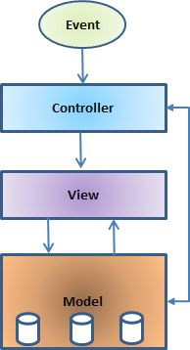

Figure 1 MVC Framework

## SHA-256 Encryption:

SHA-2 is a set of cryptographic hash functions designed by the NSA (U.S. National Security Agency). SHA stands for Secure Hash Algorithm. Cryptographic hash functions are mathematical operations run on digital data; by comparing the computed "hash" (the execution of the algorithm) to a known and expected hash value, a person can determine the data's integrity. For example, computing the hash of a downloaded file and comparing the result to a previously published hash result can show whether the download has been modified or tampered with. A key aspect of cryptographic hash functions is their one-way nature: given a computed hash value, it is very difficult to derive the original data.

SHA-2 includes significant changes from its predecessor, SHA-1. The SHA-2 family consists of six hash functions with digests (hash values) that are 224, 256, 384 or 512 bits: SHA-224, SHA-256, SHA-384, SHA-512, SHA-512/224, SHA-512/256.

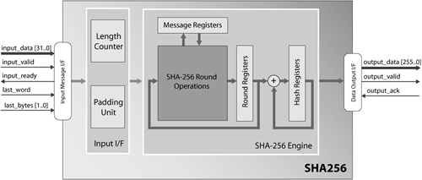SHA-256 and SHA-512 are novel hash functions computed with 32-bit and 64-bit words, respectively. They use different shift amounts and additive constants, but their structures are otherwise virtually identical, differing only in the number of rounds.

Figure 2 SHA-256 Encryption

## Dynamic Database:

## A dynamic database management system (dynamic DBMS) is a database in which objects have a value-based relationship, which is specified at retrieval time. In a dynamic DBMS, the locations of logical file databases and relational data base are value-based.

## Value-based system architecture stores and manages three basic sets of objects: a data dictionary holding metadata, indexing and linking data sets, and actual data values made up of stored information. The independent logical file database and relational databases are value-based. A dynamic DBMS is the opposite of a static database management system, where relationships are information based.

## Difference between static and dynamic database:

## A (logical) schema is fixed if it is defined before a program is written, but dynamic if it is defined by the program or data itself.

## A database is fixed- or dynamic-schema depending on whether its schemas are fixed or dynamic respectively.

## A DBMS is fixed- or dynamic-schema depending on whether databases created in it tend to have fixed or dynamic schemas

1. Project Description and Specification

**NITUK-HEAL** is a web application that allows admin to login through a valid username and password and undertake various functionalities such as registering a new person & filling his details, editing & updating his details, maintaining records of prescriptions provided to him, deleting an existing person and searching for a person by attributes such as ID, name, blood group, health problems, vaccination, counselling areas, etc. It is attached with a flawless and attractive GUI so that the user can easily use the application without any problem.

**Project Specification**

**Database: Medical_nituk**

1. **Entity : Admin**

**Attributes:**

* admin_id (primary key)
* Name
* Password
* Sec_ques
* Sec_ans

1. **Entity : Person**

**Attributes:**

* p_id (primary key)
* Name
* DOB
* Gender
* Age
* Contact
* Type

1. **Entity : Student**

**Attributes:**

* p_id (primary key) references to Person.p_id
* Department
* Year
* Hostel no.
* Room no.

1. **Entity : Staff**

**Attributes:**

* p_id (primary key) references to Person.p_id
* Department
* Year
* Address
* Type

1. **Entity : Family**

**Attributes:**

* p_id (primary key) references to Person.p_id
* Father
* Mother
* F_occupation
* M_occupation
* F_address
* F_contact
* F_history

1. **Entity : Health**

**Attributes:**

* p_id (primary key) references to Person.p_id
* Present_n_Past
* Personal
* Counselling
* Blood-group
* HepatitisB
* MMR
* Tetanus
* HepatitisA
* Chickenpox
* Typhoid

1. **Entity : Health_1**

**Attributes:**

* p_id (primary key) references to Health.p_id
* Height
* Weight
* Blood Pressure
* Vision
* Dental
* Chest
* Abdomen
* Other
* Advice

1. **Entity : Health_2**

**Attributes:**

* p_id (primary key) references to Health.p_id
* Height
* Weight
* Blood Pressure
* Vision
* Dental
* Chest
* Abdomen
* Other
* Advice

1. **Entity : Health_3**

**Attributes:**

* p_id (primary key) references to Health.p_id
* Height
* Weight
* Blood Pressure
* Vision
* Dental
* Chest
* Abdomen
* Other
* Advice

1. **Entity : Health_4**

**Attributes:**

* p_id (primary key) references to Health.p_id
* Height
* Weight
* Blood Pressure
* Vision
* Dental
* Chest
* Abdomen
* Other
* Advice

1. **Entity : Health_5**

**Attributes:**

* p_id (primary key) references to Health.p_id
* Height
* Weight
* Blood Pressure
* Vision
* Dental
* Chest
* Abdomen
* Other
* Advice

**Database: prescription**

1. **Entity : Dynamicaly based on Person.p_id**

**Attributes:**

* name
* age
* date
* pres
* adv

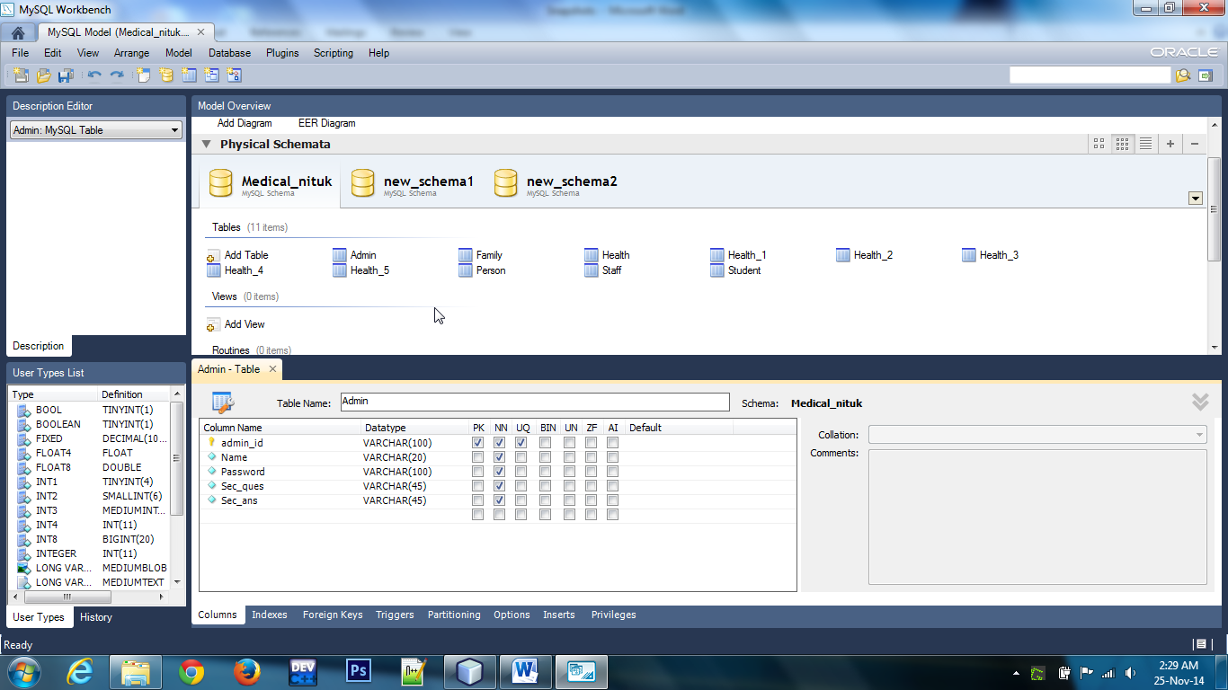

Figure 3 Database entities

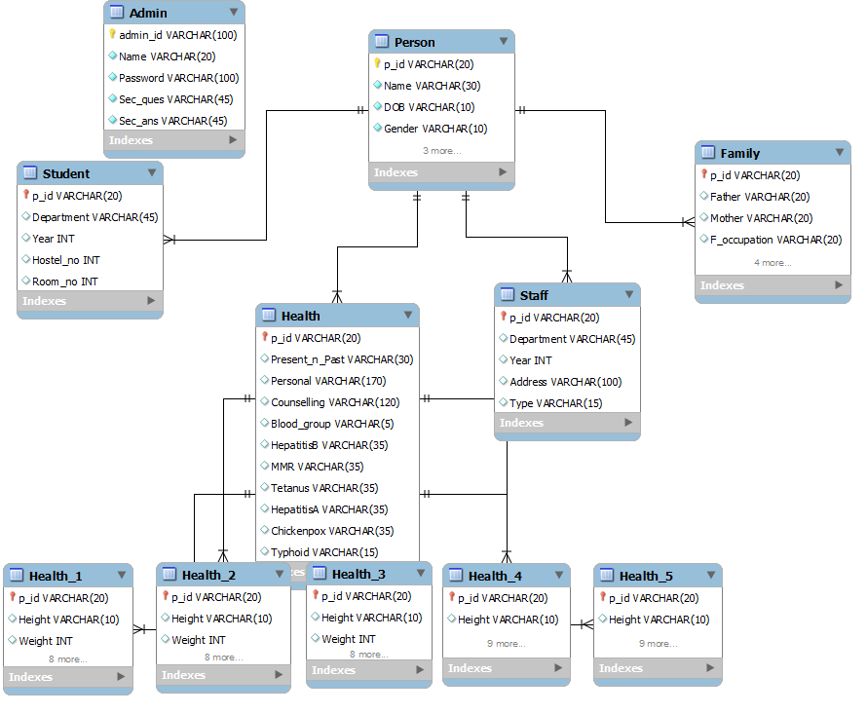

Figure 4 Entity-Relationship diagram

**Project Description**

The application design uses the modular approach. The complete project can be divided into 3 main modules:

* Login Module
* Update Module
* Search Module
* View Module

## Login Module

This module is responsible for secured login of the administrator. A master password is provided to the authorized party so that only authenticated persons that are authenticated by the authorized party can register themselves as the administrator. Whenever a person wants to register as an administrator, he/she will use the master password provided, after which Admin ID and Admin password (generated dynamically) will be provided to him/her. The administrator can then use this Admin ID and password to login. The administrator can also change the password. In case the administrator forgets the password, he/she will be asked for a security question provided by him/herself at the time of register.

The passwords are encrypted with SHA-256 encryption to ensure security of the database it maintained and to prevent any type of attacks on the password.

## Update Module

This is the main module that manages insertion, deletion & updating the medical details of a person in the database. It is also be responsible for updating the basic details of the person and updating the prescription provided to the person each time he/she consults the doctor to maintain a record of the medical history of that person. Separate tables are created for each person dynamically for prescription.

The update module can be divided into 5 sub-modules

* + 1. **Basic Details:** This modules updates the basic details of the person including his/her department, his type (student, teaching/non-teaching), address, etc.
    2. **Health Profile:** This module updates the health profile of a person. The health profile of a person contains many attributes such as weight, height, vision, blood group, his vaccination details, etc. The health profile of a person is updated every year.
    3. **Family Details:** This module deals with updating the details of the person’s family such as father’s name, mother’s name, occupation, etc. It also updates the family medical history to check for some common hereditary health problems present in the family such as diabetes, high blood pressure, etc.
    4. **Medical History:** This modules concentrates on the medical history of the person. It updates all the past medical information about the person such as major operations or any major past health problem. It also maintain records of present status of the person, whether he is under any medical supervision, indulged in any physical activities, etc. Also, a list of the areas in which a person requires counselling is maintained so that it can be reviewed later on.
    5. **Prescription:** This module maintains a dynamically created table for each registered person in the database. It includes all the information about the prescription provided to the person by the college medical authorities. It includes information about the date, medicines referred and advice provided by the doctor to that person when a person seeks medical attention while his/her stay in the college.

## Search Module

## This module is responsible for searching the entries in the database. The administrator can easily search the database with the help of various attributes.

## The complete personal details of a person can be obtained by searching the person using his/her id.

## The search can also be made using various other attributes, such as the name of the person, the personal problems or the counselling areas, family history, blood group, etc. A Search Result page will appear that will contain the list of all the person that satisfies the query entered at the time of the search. The administrator can view complete details about each person on the list by clicking over that result.

## e.g. Suppose if the administrator wants to know how many people in the college requires counselling on economic issues , then he can search for the people containing economic issues in their counselling areas. This will provide him the complete list of persons that requires counselling in economic issues.

## View Module

This module handles all the user interface design features provided to the users.

The view module is designed in such a way that it provides flawless design to ensure good user experience.

It can be further divided into multiple modules:

* + 1. **Register View Module:**

If the user is not a registered user, he/she will register in the application. The register module asks for user name, a master password, a security question and a security answer, to be used in case the user forgets the password. If the master password matches, a User ID and a password will be provided to the user which will be used by the user to login.

* + 1. **Login View Module:**

If the user is a registered user, the user will login through this module.The module will check if the User ID and password matches, if it does it redirects to the next module or else, will generate an error message. The user can also change his/her password if he has forget the password by correctly answering the security question provided at the time of register.

* + 1. **Update View Module:**

This module will be active every time the administrator wants to register a new person or update the details of an existing person in the database. This module will also allow administrator to delete the details of a person from the database. This modules interacts with the update module to make changes to the database.

* + 1. **Search Module:**

This module is used by the user to search over the medical database. It provides multiple facilities, such as:

* To get complete details of a person (using ID)
* To search a person using name
* To search a person on basis of his/her family history
* To search a person on the basis of vaccination
* To search a person on the basis of areas in which counselling is required
* To search a person on the basis of his/her present or past problems
* Settings, to change administrator password, if required.

After the user submits a query, the search module redirects to the result page, which contains all the results. All the entries in the result page are clickable and complete details of a person from the result list can be obtained by clicking over the result. The user can return to home, or logout any time.

The complete application can be briefly represented by the following flow diagram:

Start App

**Registered**

**NO**

**Login Module**

**YES**

**Password**

**Matched**

**NO**

**Register Module**

**Registered**

**Search**

**YES**

**Admin Page**

**Search Module**

**Delete Person**

**Register Person**

**Doesn’t Exist**

**Check ID**

**Edit Person**

Registered

**Skip**

**Doesn’t Exist**

**Exist**

**Exist**

Deleted

**Update Details**

**Check ID**

Update Database

Update Database

Figure 5 Flowchart of NITUK-HEAL

1. **Methodology and Planning of work**

Project is entirely based on language like java, javascript, ajax, html and css,xml. The technology we used are jsp, servlets and struts.Also the features provided by Java as an object oriented language adds in the key feature which is needed by this project.

Besides this other various tools used were:

* 1. **Softwares:**
     1. **Netbeans:**

Netbeans is an [integrated development environment](http://en.wikipedia.org/wiki/Integrated_development_environment) used to develop applications in many languages such as Java, C, PHP, C++, HTML,etc. It contains a base [workspace](http://en.wikipedia.org/wiki/Workspace) and an extensible [plug-in](http://en.wikipedia.org/wiki/Plug-in_%28computing%29) system for customizing the environment. It is also an application platform framework for Java desktop applications and others.

The NetBeans IDE is written in Java and can run on Windows, OS X, Linux, Solaris and other platforms supporting a compatible JVM. Users can extend its abilities by installing plug-ins written for the Eclipse Platform, such as development toolkits for other programming languages, and can write and contribute their own plug-in modules.

The platform offers reusable services common to desktop applications, allowing developers to focus on the logic specific to their application. Among the features of the platform are:

* User interface management (e.g. menus and toolbars)
* User settings management
* Storage management (saving and loading any kind of data)
* Window management
* Wizard framework (supports step-by-step dialogs)
* NetBeans Visual Library
* Integrated development tools

NetBeans IDE is a free, open-source, cross-platform IDE with built-in-support for Java Programming Language.

* + 1. **MySQLWorkbench**

MySQL Workbench is a visual database design tool that integrates SQL development, administration, database design, creation and maintenance into a single integrated development environment for the MySQL database system.

Prominent features of MySQL Workbench are:

**General**

* Database Connection & Instance Management
* Wizard driven action items
* Fully scriptable with Python and Lua
* Support for custom plugins
* MSAA (Windows Accessibility API) compliant
* Supports MySQL Enterprise features (Audit log and MEB)

**SQL Editor**

* Schema object browsing, inspection, and search
* SQL syntax highlighter and statement parser
* SQL code completion and context sensitive help
* Multiple and editable result sets
* Visual EXPLAIN
* SQL snippets collections
* SSH connection tunneling
* Unicode support

**Data modeling**

* ER diagramming
* Drag'n'Drop visual modeling
* Reverse engineering from SQL Scripts and live database
* Forward engineering to SQL Scripts and live database
* Schema synchronization
* Printing of models
* Import from fabFORCE.net DBDesigner4
* Database administration
* Start and stop of database instances
* Instance configuration
* Database account management
* Instance variables browsing
* Log file browsing
* Data dump export/import

**Performance monitoring**

* Performance Schema metrics
* MySQL instance dashboard
* Query statistics

**Database migration**

* Any ODBC compliant database
* Native support: Microsoft SQL Server, PostgreSQL, SQL Anywhere, SQLite, and Sybase ASE
  1. **Programming Language:**
     1. **JAVA**

Java is a [computer programming language](http://en.wikipedia.org/wiki/Computer_programming_language) that is [concurrent](http://en.wikipedia.org/wiki/Concurrent_computing), [class-based](http://en.wikipedia.org/wiki/Class-based), [object-oriented](http://en.wikipedia.org/wiki/Object-oriented_programming), and specifically designed to have as few implementation dependencies as possible. It is intended to let application developers "[write once, run anywhere](http://en.wikipedia.org/wiki/Write_once,_run_anywhere)", meaning that code that runs on one platform does not need to be recompiled to run on another. Java applications are typically [compiled](http://en.wikipedia.org/wiki/Compiler) to [byte code](http://en.wikipedia.org/wiki/Java_bytecode) ([class file](http://en.wikipedia.org/wiki/Class_%28file_format%29)) that can run on any [Java virtual machine](http://en.wikipedia.org/wiki/Java_virtual_machine) regardless of [computer architecture](http://en.wikipedia.org/wiki/Computer_architecture). Java is one of the most popular programming languages in use, particularly for client-server web applications.

* + 1. **JAVASCRIPT and JQUERY**

JavaScript is a [dynamic](http://en.wikipedia.org/wiki/Dynamic_programming_language) computer [programming language](http://en.wikipedia.org/wiki/Programming_language). It is most commonly used as part of [web browsers](http://en.wikipedia.org/wiki/Web_browser), whose implementations allow [client-side scripts](http://en.wikipedia.org/wiki/Client-side_scripting) to [interact with the user](http://en.wikipedia.org/wiki/User_interface), control the browser, communicate [asynchronously](http://en.wikipedia.org/wiki/Ajax_(programming)), and alter the [document content](http://en.wikipedia.org/wiki/Document_Object_Model) that is displayed. It is also being used in server-side programming, game development and the creation of desktop and mobile applications.

JQuery is a [cross-platform](http://en.wikipedia.org/wiki/Cross-platform) [JavaScript library](http://en.wikipedia.org/wiki/JavaScript_library) designed to simplify the [client-side scripting](http://en.wikipedia.org/wiki/Client-side_scripting) of [Hypertext](http://en.wikipedia.org/wiki/HTML) Markup Language. JQuery is the most popular [JavaScript library](http://en.wikipedia.org/wiki/JavaScript_library) in use today. JQuery’s syntax is designed to make it easier to navigate a document, select [DOM](http://en.wikipedia.org/wiki/Document_Object_Model) elements, create [animations](http://en.wikipedia.org/wiki/Animation), handle [events](http://en.wikipedia.org/wiki/Event_(computing)), and develop [Ajax applications](http://en.wikipedia.org/wiki/Ajax_(programming)). JQuery also provides capabilities for developers to create [plug-ins](http://en.wikipedia.org/wiki/Plug-in_(computing)) on top of the JavaScript library. This enables developers to create [abstractions](http://en.wikipedia.org/wiki/Abstraction_(computer_science)) for low-level interaction and animation, advanced effects and high-level.

* + 1. **HYPER TEXT MARKUP LANGUAGE AND CASCADING STYLE SHEETS**

Hypertext Markup Language is the standard [markup language](http://en.wikipedia.org/wiki/Markup_language) used to create [web pages](http://en.wikipedia.org/wiki/Web_page). Hypertext Markup Language is written in the form of  [Hypertext Markup Language](http://en.wikipedia.org/wiki/HTML_element) consisting of tags enclosed in [angle brackets](http://en.wikipedia.org/wiki/Angle_brackets). Hypertext Markup Language tags most commonly come in pairs although some tags represent empty elements and so are unpaired. The first tag in a pair is the start tag, and the second tag is the end tag .Though not always necessary, it is best practice to append a slash to tags which are not paired with a closing tag. Hypertext Markup languages are used a website [semantically](http://en.wikipedia.org/wiki/Semantic) along with cues for presentation, making it a [markup language](http://en.wikipedia.org/wiki/Markup_language) rather than a [programming language](http://en.wikipedia.org/wiki/Programming_language).

Cascading Style Sheets is a [style sheet language](http://en.wikipedia.org/wiki/Style_sheet_language) used for describing the [look and formatting](http://en.wikipedia.org/wiki/Presentation_semantics) of a document written in a [markup language](http://en.wikipedia.org/wiki/Markup_language)s is designed primarily to enable the separation of document content from document presentation, including elements such as the [layout](http://en.wikipedia.org/wiki/Page_layout), [colors](http://en.wikipedia.org/wiki/Color), and [fonts](http://en.wikipedia.org/wiki/Typeface). This separation can improve content [accessibility](http://en.wikipedia.org/wiki/Accessibility), provide more flexibility and control in the specification of presentation characteristics, enable multiple pages to share formatting, and reduce complexity and repetition in the structural content.

* + 1. **AJAX( Asynchronus JavaScript and XML)**

It is a group of interrelated Web development techniques used on the client-side to create asynchronous Web applications. With Ajax, Web applications can send data to and retrieve from a server asynchronously (in the background) without interfering with the display and behavior of the existing page.

Data can be retrieved using the XMLHttpRequest object. Despite the name, the use of XML is not required; JSON is often used instead and the requests do not need to be asynchronous.

* 1. **Database used:**
     1. **MYSQL database**

MySQL is a popular choice of database for use in web applications, and is a central component of the widely used LAMP open source web application software stack (and other 'AMP' stacks). LAMP is an acronym for "Linux, Apache, MySQL, Perl/PHP/Python." Free-software-open source projects that require a full-featured database management system often use MySQL.

MySQL is offered under two different editions: the open source MySQL Community Server and the proprietary Enterprise Server.[34] MySQL Enterprise Server is differentiated by a series of proprietary extensions which install as server plugins, but otherwise shares the version numbering system and is built from the same code base.

Major features as available in MySQL 5.6:

* A broad subset of ANSI SQL 99, as well as extensions
* Cross-platform support
* Stored procedures, using a procedural language that closely adheres to SQL/PSM[35]
* Triggers
* Cursors
* Updatable views
* Online DDL when using the InnoDB Storage Engine.
* Information schema
* Performance Schema
* A set of SQL Mode options to control runtime behavior, including a strict mode to better adhere to SQL standards.
* X/Open XA distributed transaction processing (DTP) support; two phase commit as part of this, using the default InnoDB storage engine
* Transactions with savepoints when using the default InnoDB Storage Engine. The NDB Cluster Storage Engine also supports transactions.
* ACID compliance when using InnoDB and NDB Cluster Storage Engines[36]
* SSL support
* Query caching
* Sub-SELECTs (i.e. nested SELECTs)
* Built-in Replication support (i.e. Master-Master Replication & Master-Slave Replication) with one master per slave, many slaves per master.[37] Multi-master replication is provided in MySQL Cluster,[38] and multi-master support can be added to unclustered configurations using Galera Cluster.[39]
* Full-text indexing and searching[b]
* Embedded database library
* Unicode support[c]
* Partitioned tables with pruning of partitions in optimizer
* Shared-nothing clustering through MySQL Cluster
  1. **Technologies Used**
     1. **JSP (Java Server Pages)**

JavaServer Pages (JSP) is a technology that helps software developers create dynamically generated web pages based on HTML, XML, or other document types. Architecturally, JSP may be viewed as a high-level abstraction of Java servlets. JSPs are translated into servlets at runtime; each JSP servlet is cached and re-used until the original JSP is modified.

JSP can be used independently or as the view component of a server-side model–view–controller design, normally with JavaBeans as the model and Java servlets (or a framework such as Apache Struts) as the controller.

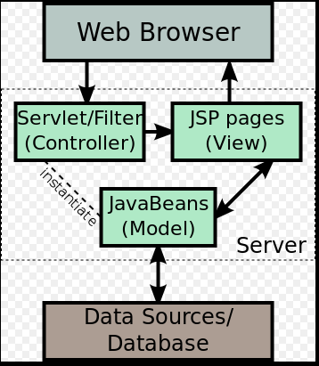

Figure 6 JSP Model View Controller Design

JSP allows Java code and certain pre-defined actions to be interleaved with static web markup content, with the resulting page being compiled and executed on the server to deliver a document. The compiled pages, as well as any dependent Java libraries, use Java bytecode rather than a native software format. Like any other Java program, they must be executed within a Java virtual machine (JVM) that integrates with the server's host operating system to provide an abstract platform-neutral environment.

JSPs are usually used to deliver HTML and XML documents, but through the use of OutputStream, they can deliver other types of data as well.

The Web container creates JSP implicit objects like pageContext, servletContext, session, request & response.

* + 1. **Servlet:**

The servlet is a Java programming language class used to extend the capabilities of a server. Although servlets can respond to any types of requests, they are commonly used to extend the applications hosted by web servers, so they can be thought of as Java applets that run on servers instead of in web browsers.These kinds of servlets are the Java counterpart to other dynamic Web content technologies such as PHP and ASP.NET.

Servlets are most often used to:

* Process or store data that was submitted from an HTML form.
* Provide dynamic content such as the results of a database query
* Manage state information that does not exist in the stateless HTTP protocol, such as filling the articles into the shopping cart of the appropriate customer

To deploy and run a servlet, a web container must be used. A web container (also known as a servlet container) is essentially the component of a web server that interacts with the servlets. The web container is responsible for managing the lifecycle of servlets, mapping a URL to a particular servlet and ensuring that the URL requester has the correct access rights.

The Servlet API, contained in the Java package hierarchy javax.servlet, defines the expected interactions of the web container and a servlet.

A Servlet is an object that receives a request and generates a response based on that request. The basic Servlet package defines Java objects to represent servlet requests and responses, as well as objects to reflect the servlet's configuration parameters and execution environment. The package javax.servlet.http defines HTTP-specific subclasses of the generic servlet elements, including session management objects that track multiple requests and responses between the web server and a client. Servlets may be packaged in a WAR file as a web application.

* + 1. **Struts :**

Apache Struts was an open-source web application framework for developing Java EE web applications. It uses and extends the Java Servlet API to encourage developers to adopt a model–view–controller (MVC) architecture.

**Model–view–controller (MVC)** is a software architectural pattern for implementing user interfaces. It divides a given software application into three interconnected parts, so as to separate internal representations of information from the ways that information is presented to or accepted from the user.

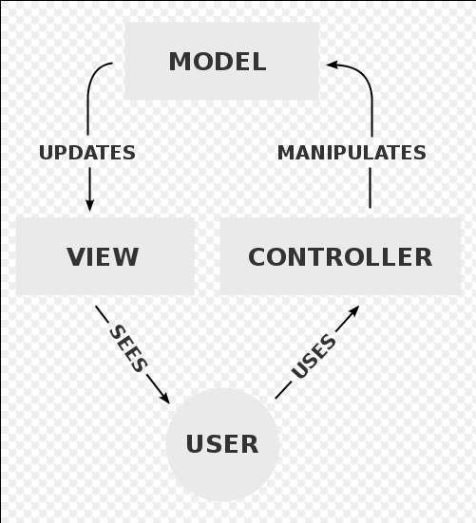

Figure 7 MVC framework

In a standard Java EE web application, the client will typically call to the server via a web form. The information is then either handed over to a Java Servlet which interacts with a database and produces an HTML-formatted response, or it is given to a JavaServer Pages (JSP) document that inter mingles HTML and Java code to achieve the same result. Both approaches are often considered inadequate for large projects because they mix application logic with presentation and make maintenance difficult.

The goal of Struts is to separate the model (application logic that interacts with a database) from the view (HTML pages presented to the client) and the controller (instance that passes information between view and model). Struts provides the controller (a servlet known as ActionServlet) and facilitates the writing of templates for the view or presentation layer. The web application programmer is responsible for writing the model code, and for creating a central configuration file struts-config.xml that binds together model, view, and controller.

1. **Future Scope**

* At present level, this application is running on local server, but in near future the extended version will run directly from the online server and more number of users can use this application at a time and more efficiently by maintaining a permanent database.
* At present level, there is less no. of check-up parameters. But in near future, there would be more no. of parameters which will examine the body precisely.
* At present level, there is no facility for a person to see his details, all operations are done by the administrator only. But in near future, each person will have the facility to see their personal and medical details but can’t manipulate them.
* In present version the application is used only in windows operating system, but in near future the application can be advanced to be used by more no. of platforms such as android, windows, ios, etc.

1. **Snapshots**

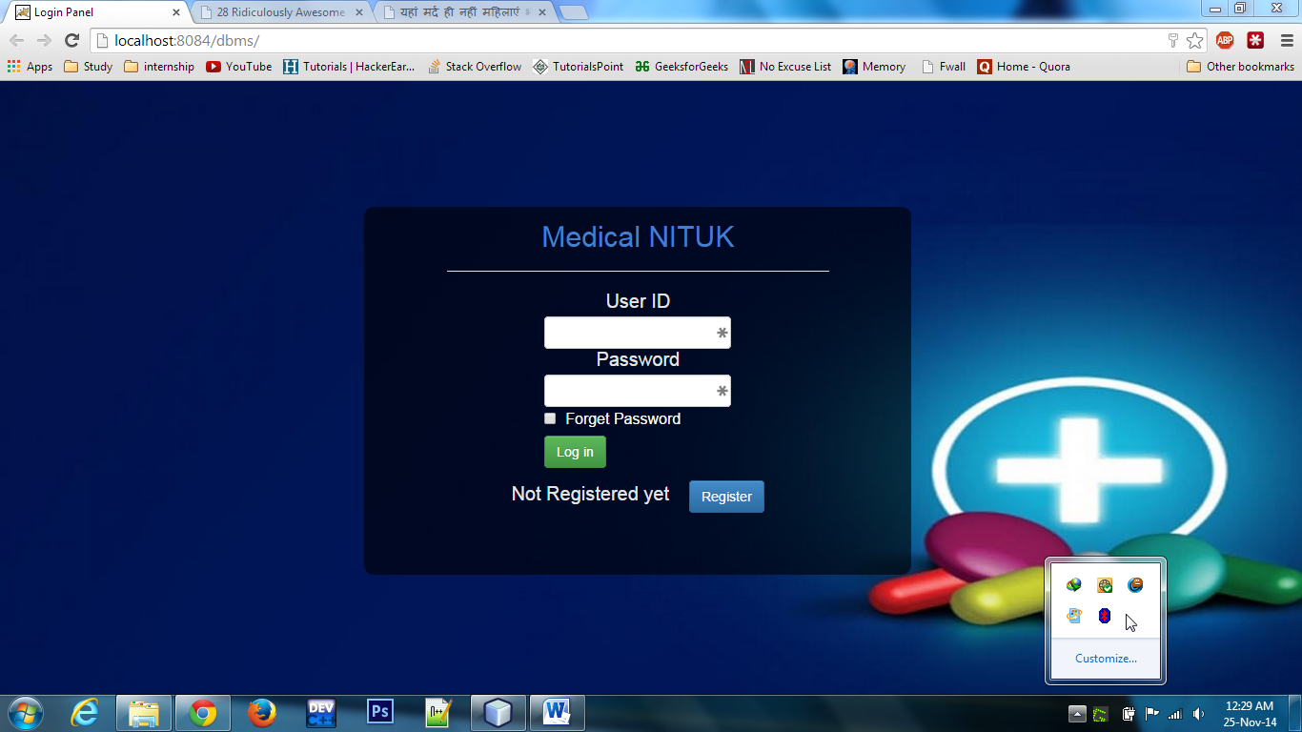

Figure 8: StarPage

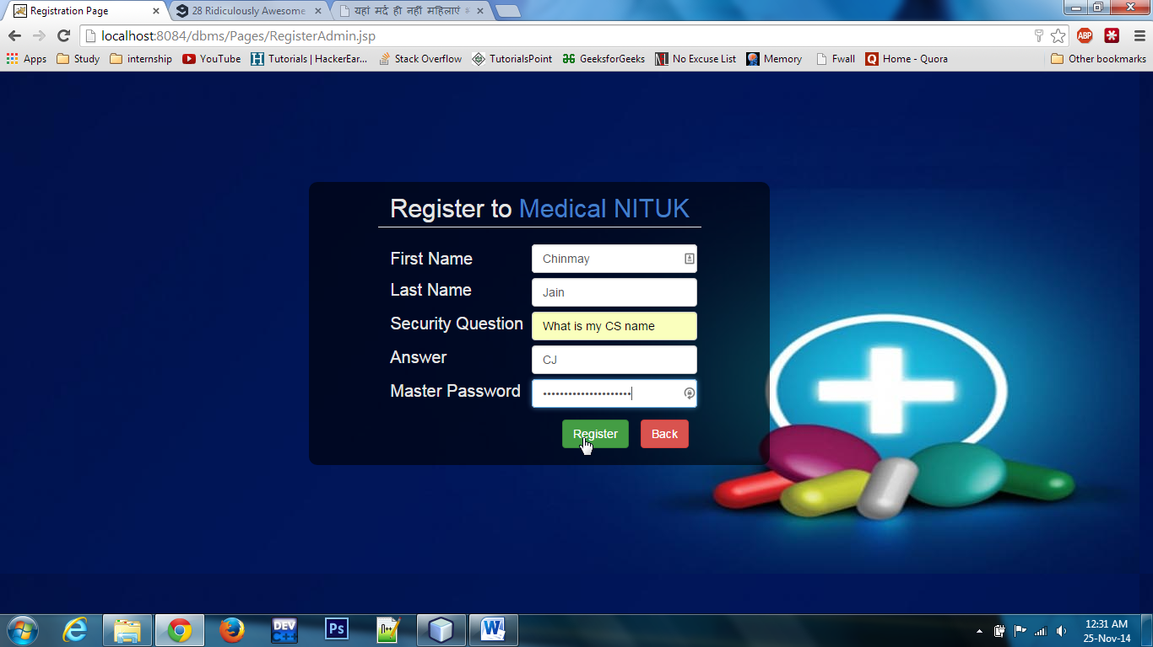

Figure 9 : Registration Page

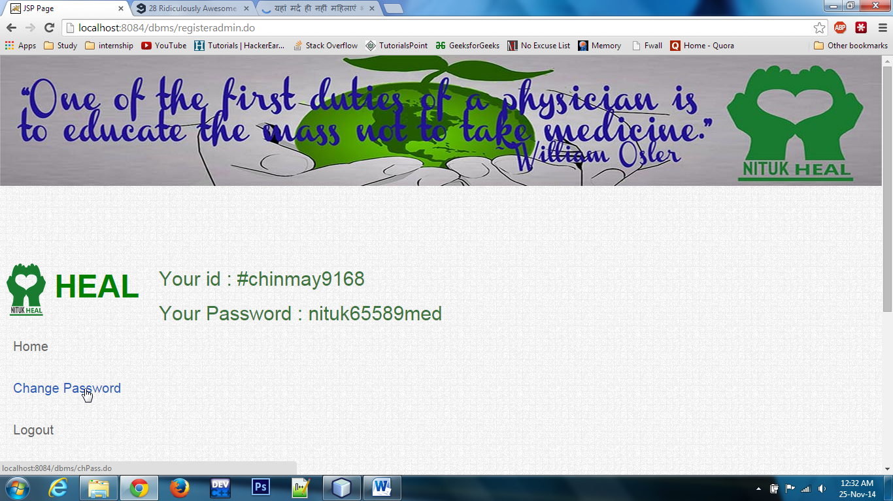

Figure 10: Registration Success

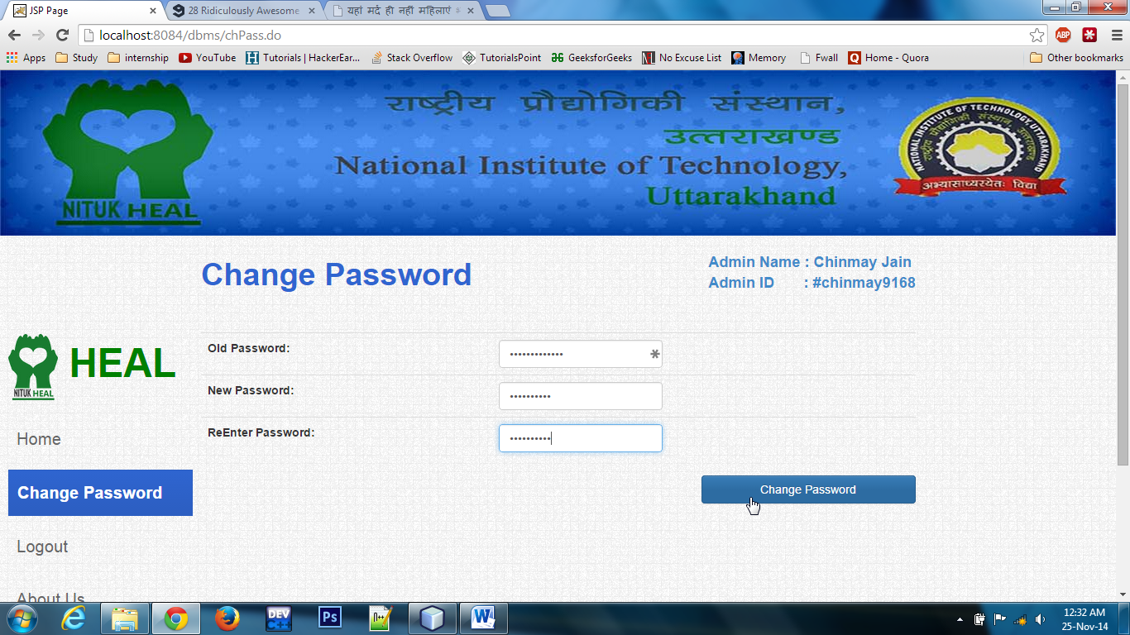

Figure 11: Change Password

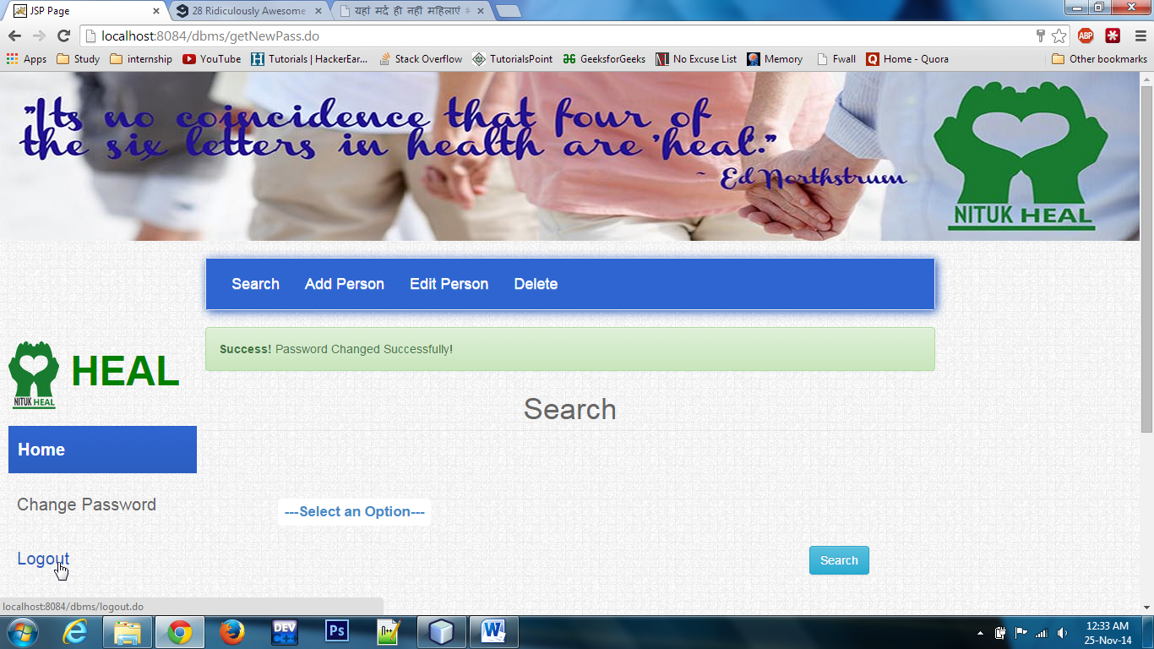

Figure 12 : Home NITUK-Heal

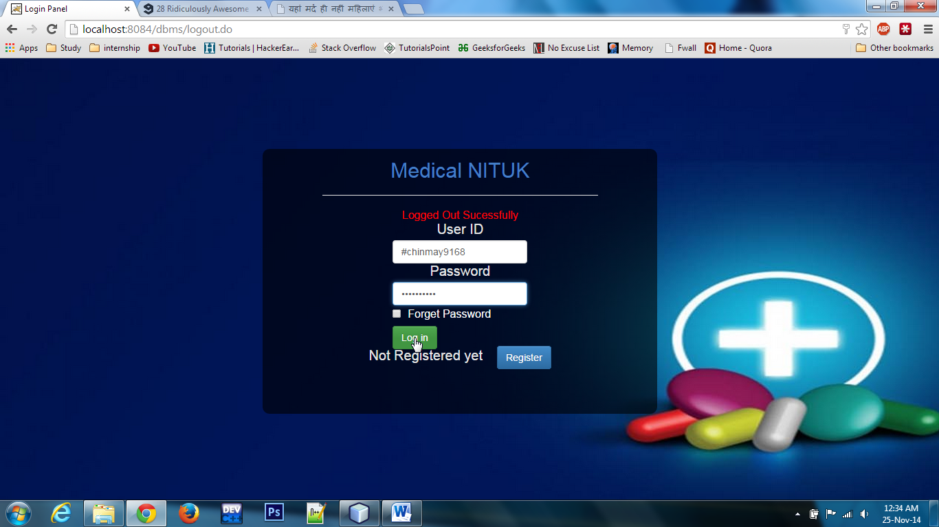

Figure 13: Log in

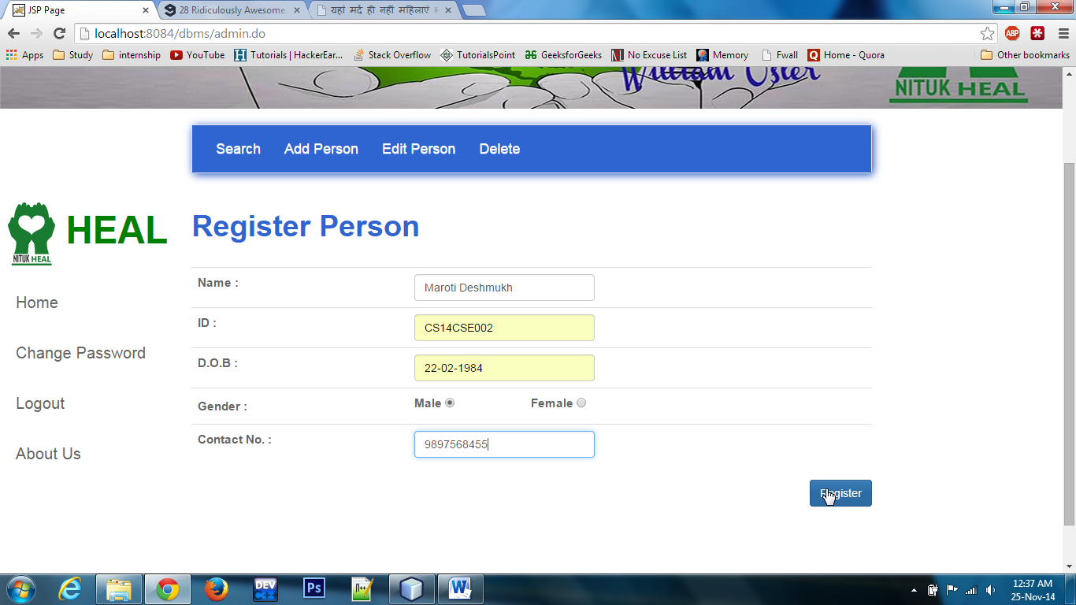

Figure 14: Register Person

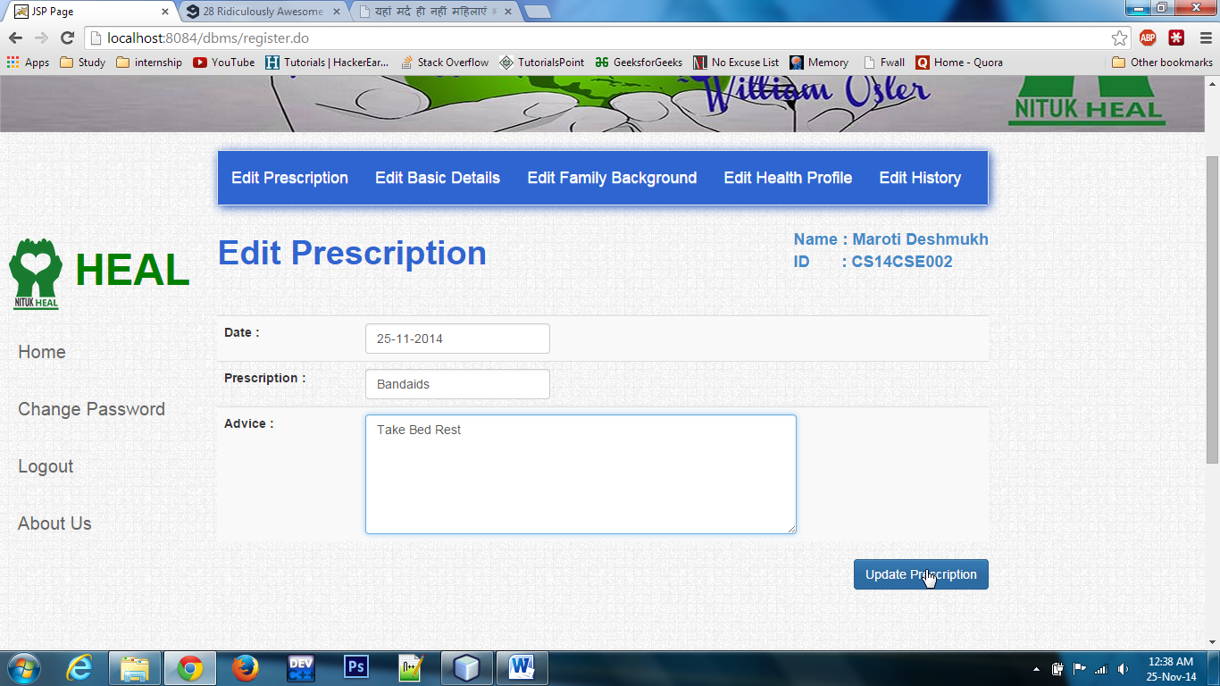

Figure 15: Edit Prescription

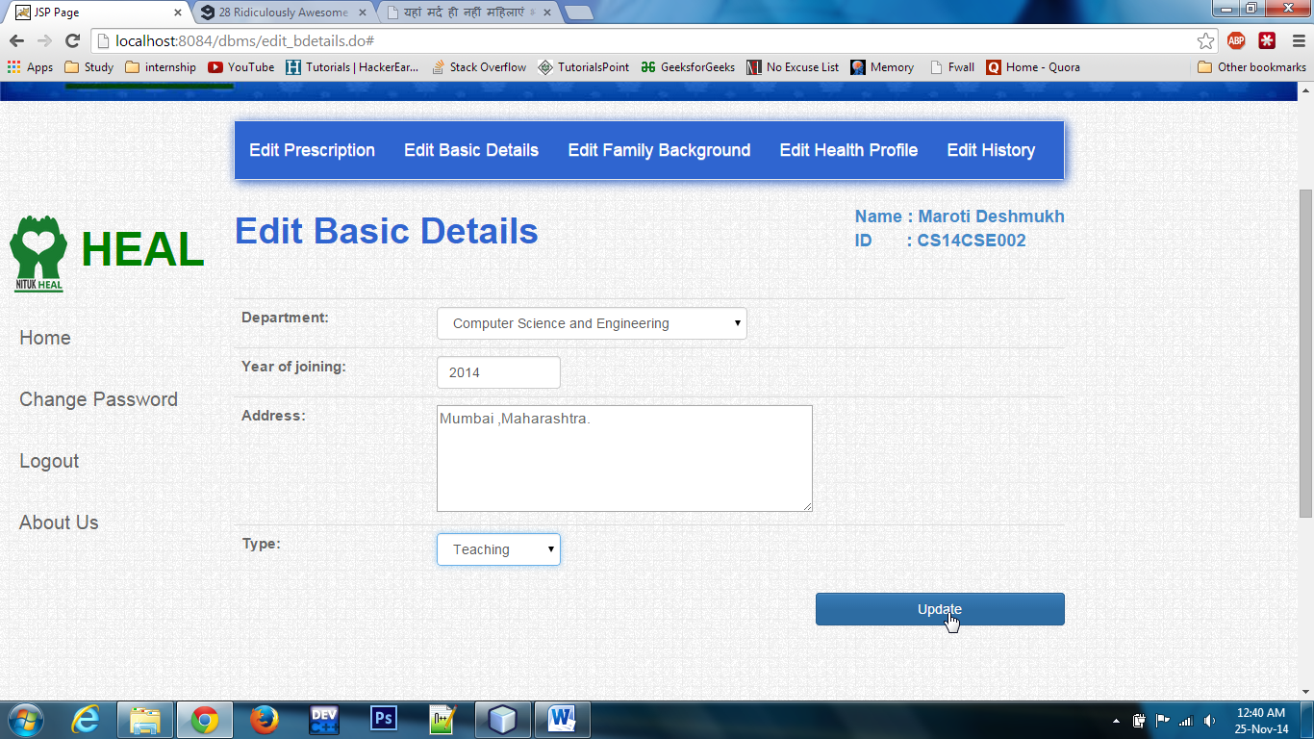

Figure 16: Edit Basic Details

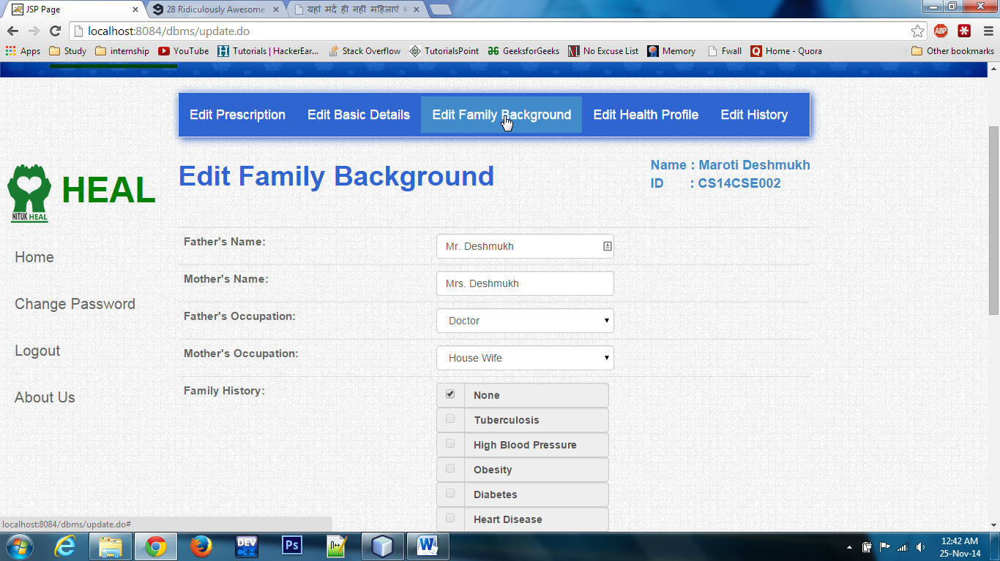

Figure 17: Edit Family Background

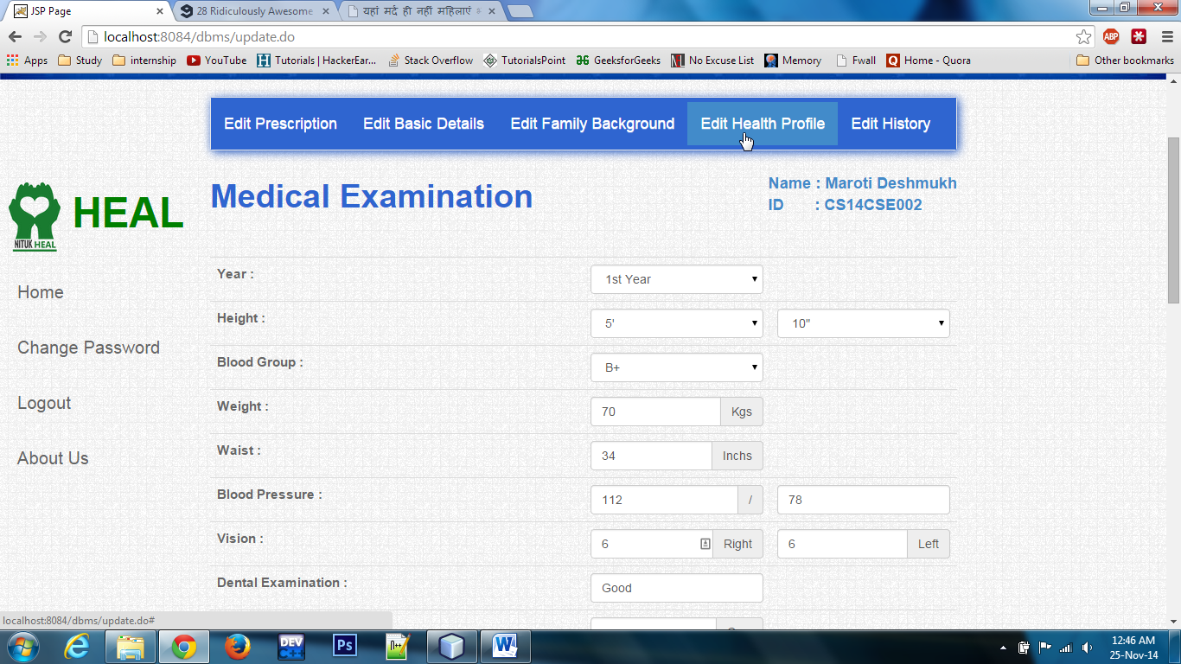

Figure 18: Edit Medical Details

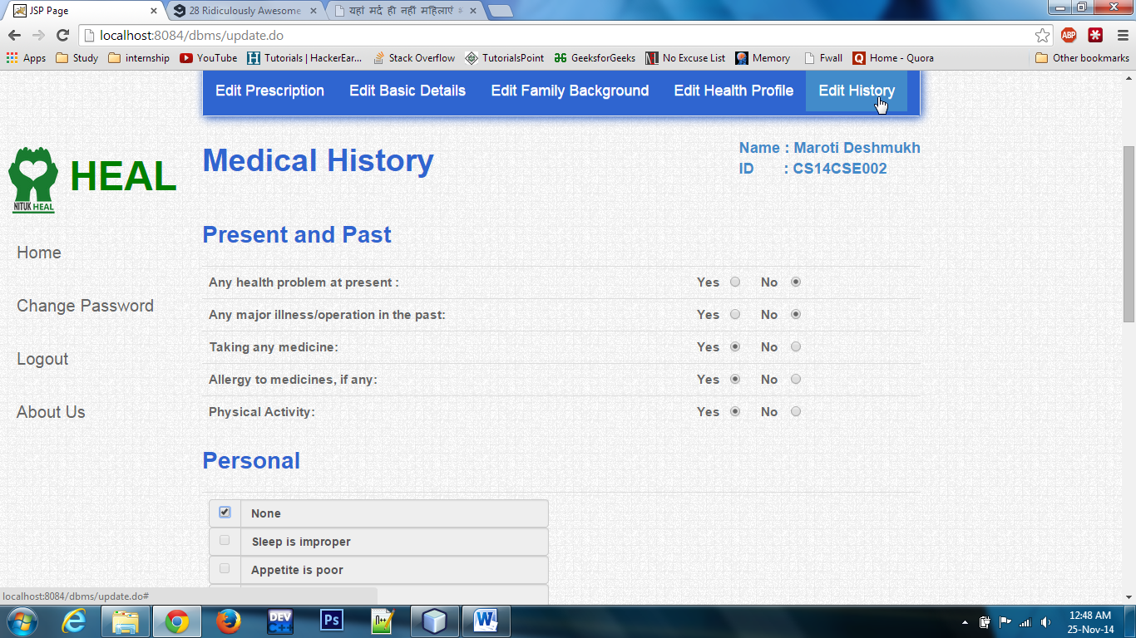

Figure 19: Edit Medical History

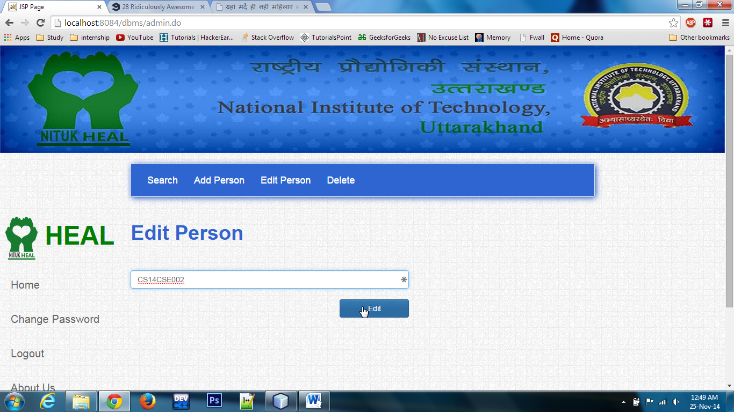

Figure 20 : Edit existing person

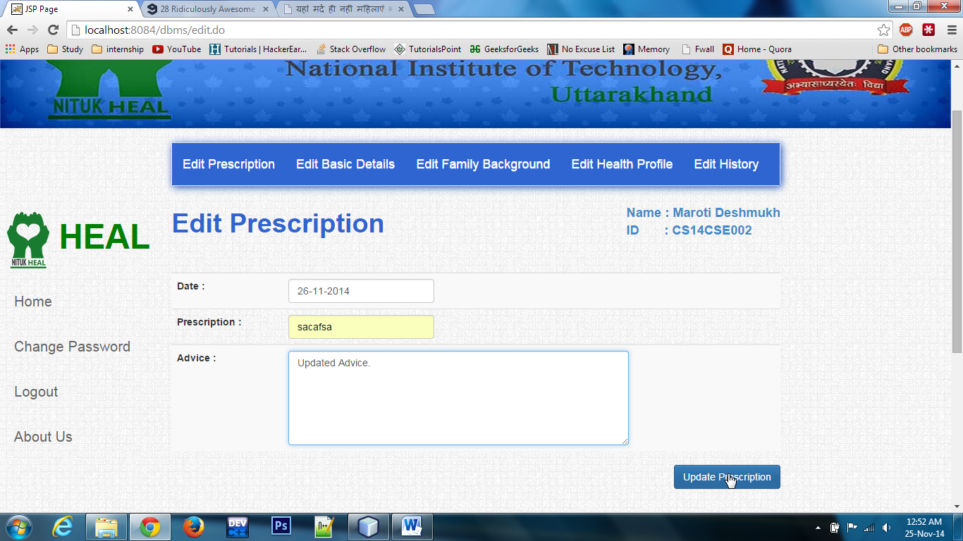

Figure 21 : Edit Prescription

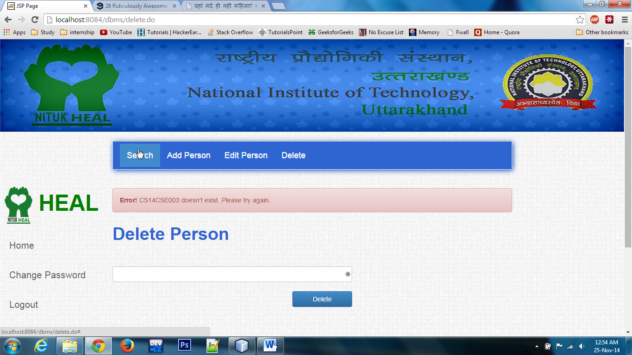

Figure 22 : Delete existing person

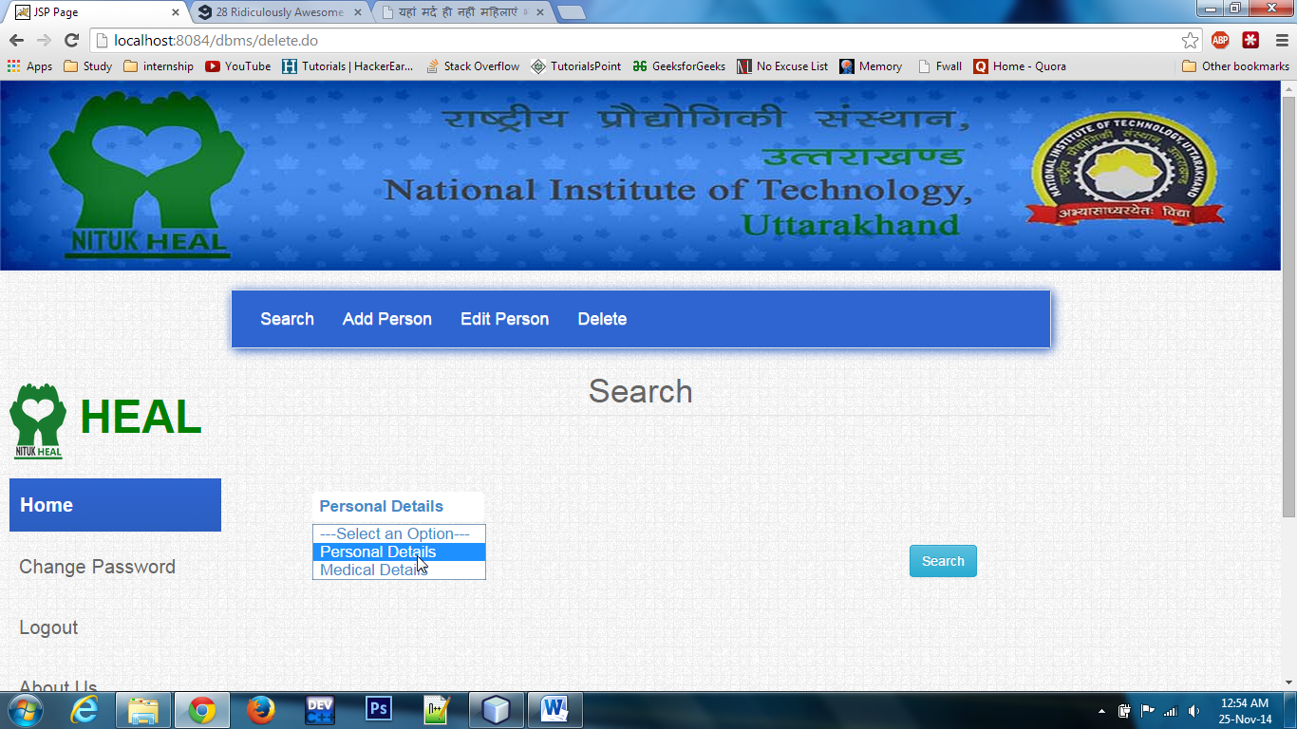

Figure 23 : Search person

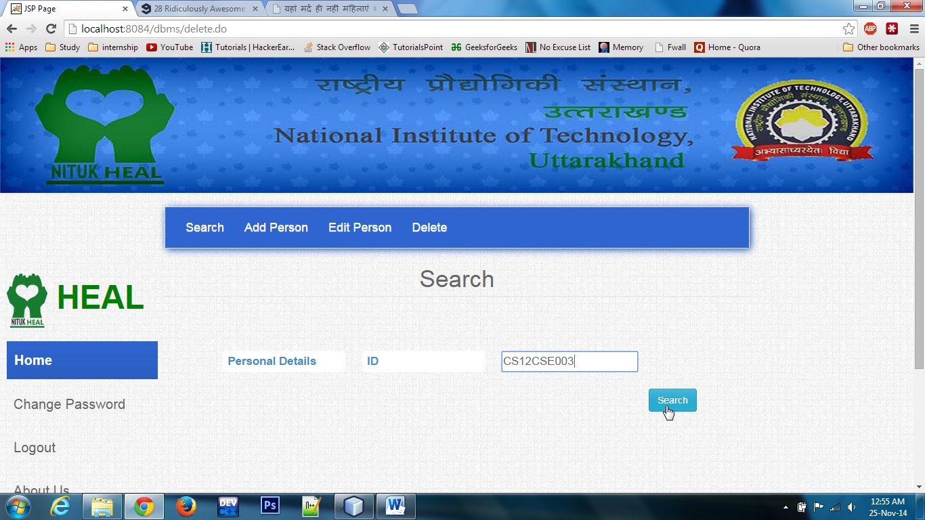

Figure 24 : Search person

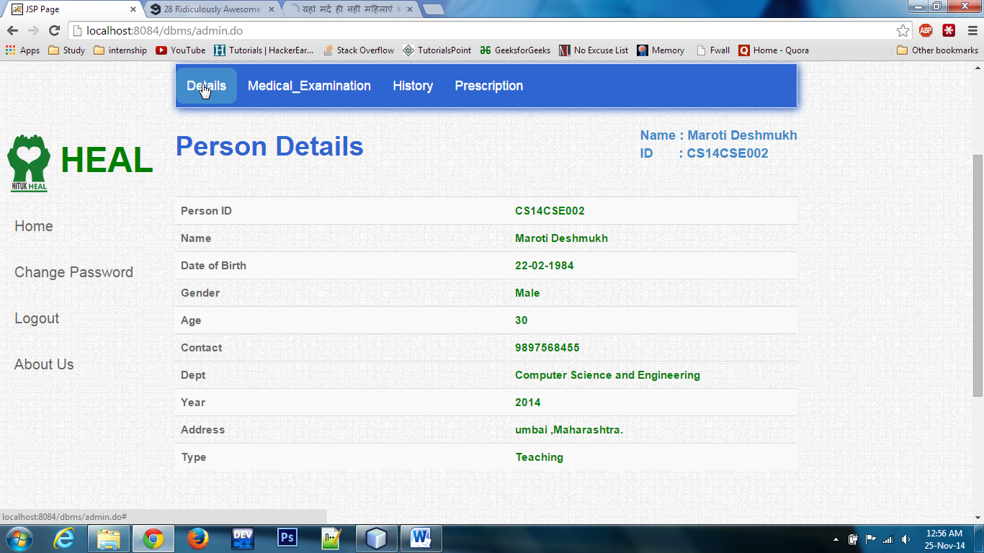

Figure 25 : Basic Details

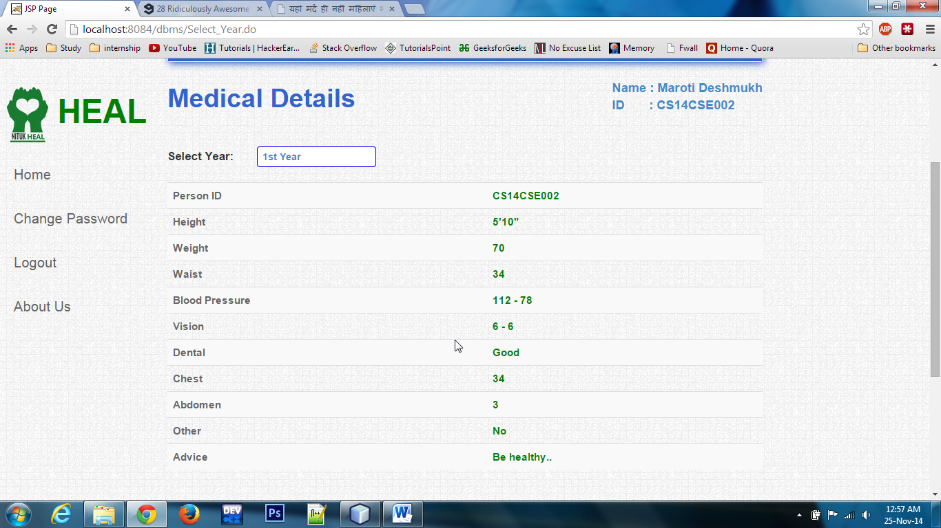

Figure 26: Medical Details

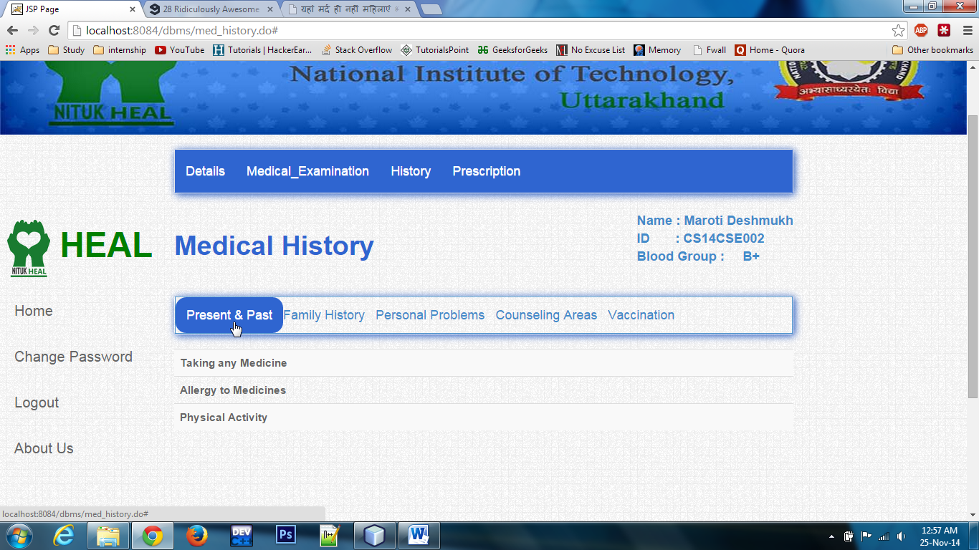

Figure 27: Medical History

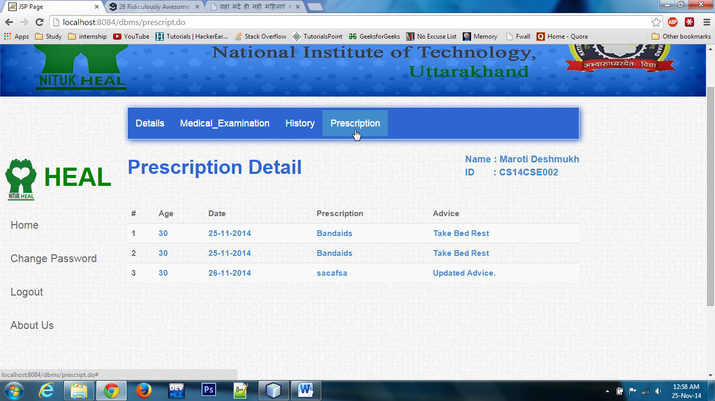

Figure 28: Prescription Details

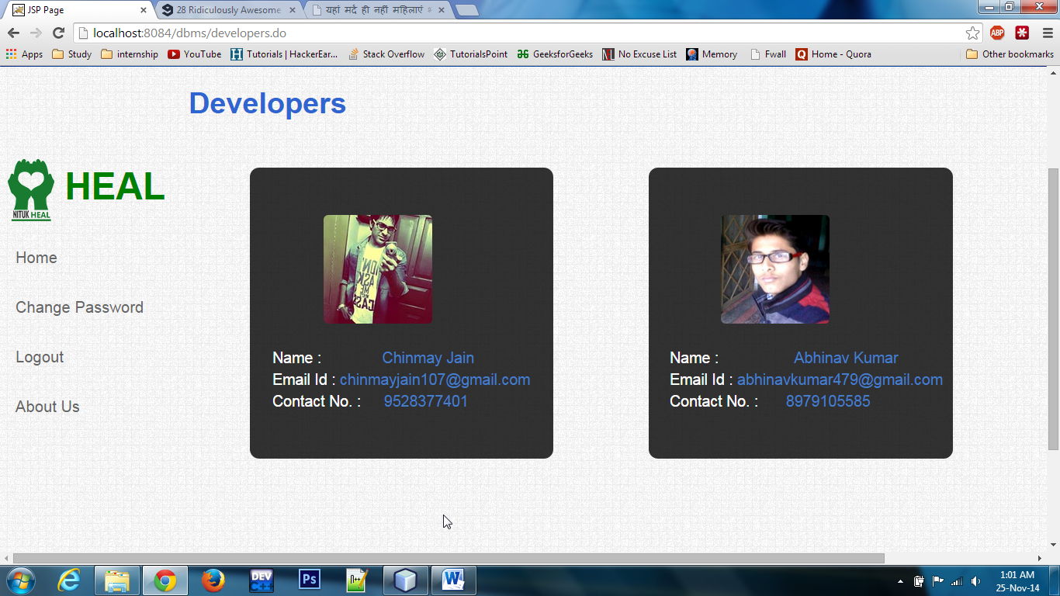

Figure 29 : Developers Page

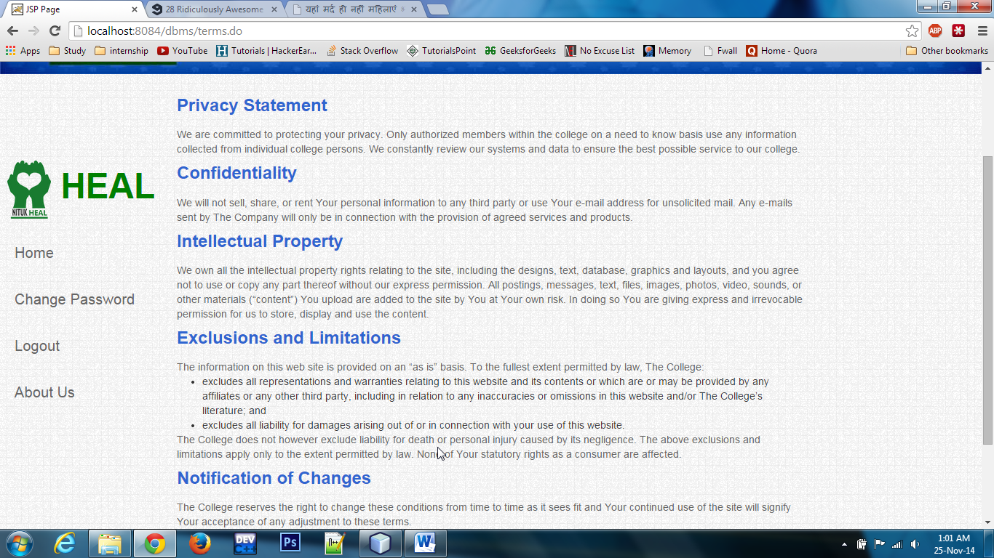

Figure 30 : Terms and Condition

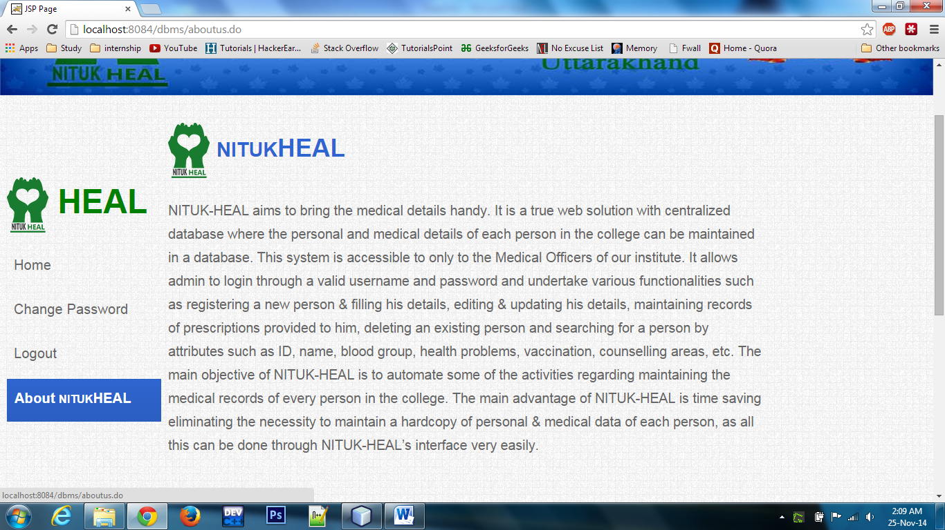

Figure 31 : About NITUKHEAL

# **References**

1. Elizabeth Robson and Eric Freeman, “Head First HYPER TEXT MARKUP LANGUAGE and CSS”, 4th Edition.
2. SQL in a Nutshell by O’Reilly
3. <http://www.stackoverflow.com>
4. <http://startbootstrap.com/template-overviews/full-slider/>
5. <http://www.java2s.com/Code/Java/Database-SQL-JDBC/HowtoserializedeserializeaJavaobjecttotheMySQLdatabase.htm>
6. <http://www.tek-tips.com/faqs.cfm?fid=5201>
7. <http://en.wikipedia.org/wiki/Model%E2%80%93view%E2%80%93controller>
8. [http://www.w3schools.com/**sql**](http://www.w3schools.com/sql)
9. <http://sql.learncodethehardway.org/book/>
10. <http://www.dustindiaz.com/add-and-remove-html-elements-dynamically-with-javascript/>
11. <http://stackoverflow.com/questions/14959690/using-dynamic-sql-to-create-a-table>